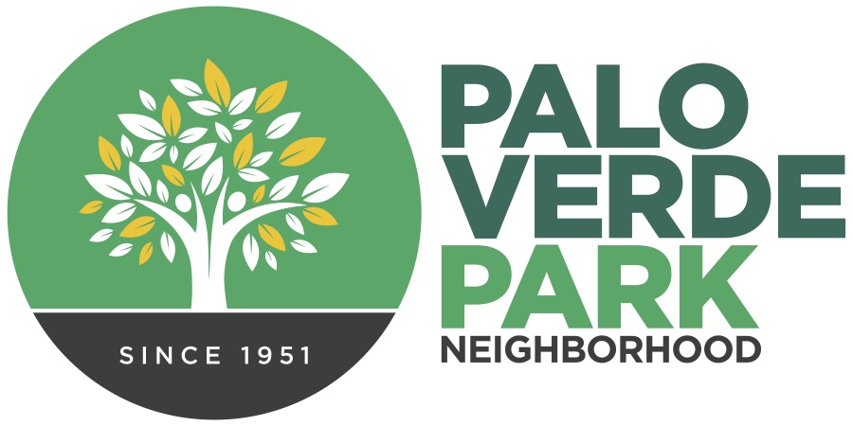
Palo Verde Park
Neighborhood Association
http://paloverdeparkneighborhood.com/

Meeting Agenda
Tuesday, January 13, 2024
11 a.m.; Palo Verde Park by Mural

President: Alfredo Araiza
Vice President: Dianne Bustamante
Treasurer: Andy Weiss
Secretary: Rhonda Bodfield
Delegate: Cathy Cromwell/Matt Russell
Delegate: Torey Crandell
Delegate: Patricia Bowers
Delegate: Adam Freden
D

*Members of the neighborhood council may attend on occasion via telephone or appoint a designee to serve

Notice of public participation
At least 14 days notice shall be provided in advance of any association meeting, barring any item of critical need, and an agenda shall be posted for public review at that time on the association website. All meetings shall be open to the public.
Out of respect for time, speakers are limited to 2 minutes on any topic.
One person speaks at a time, to allow for respectful listening.
No derogatory remarks of others will be tolerated.

- Roll Call and introductions

- Code of conduct

- President’s report

- Officers’ report, as needed

- Elections, existing slate

- Call to the Public

- Adjournment

