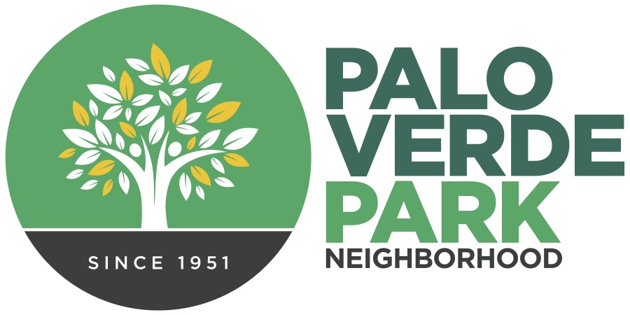
Palo Verde Park
Neighborhood Association
http://paloverdeparkneighborhood.com/

Minutes, May 16, 2023
regular meeting

Present:
Mike Southworth, president
Andy Weiss, treasurer
Rhonda Bodfield, secretary
Patricia Caldwell, delegate
Torey Crandell, delegate
Adam Freden, delegate
*Matt Russell/Cathy Cromwell, delegates, and Vice President Dianne Bustamante also serve on the Council but were unable to attend.

Regular order of business: Meeting was gaveled to order at 6:02 p.m., roll call was taken, and gratitude expressed to our hosts, Fountain of Life Church.
Minute approval: January minutes were unanimously approved from our last formal meeting and annual election in January 2023.
Guest presentations:
- City Councilman Paul Cunningham shared investment plans for the park, including funding for a covered and lit basketball court, as part of a philanthropic effort by former UA Wildcats basketball player Joe Blair. The news was met with great enthusiasm.
- Ward 2 staffer Pat Burns shared plans for a Green Stormwater Infrastructure project that will help fill the vegetation gap where a few Aleppo pines were recently removed. Pat indicated he is also looking for a few more parking spaces around the perimeter as well.
- Deputy Parks Director Greg Jackson shared an update on bond-funded projects scheduled for the park. The existing tennis courts will be converted to basketball courts, while the six planned pickleball courts will be constructed where the existing basketball courts are. New lightning will be added to the northeast softball field, as well as the west side multiuse fields. The baseball field 1 will be upgraded to LED lighting. Lighting projects are expected by the fall. Construction on the basketball and pickleball courts isn’t expected until next year.

President’s/officer’s report: Upcoming events were shared, including Tucson Water in June and Tucson Police Department in July. Plans for an October movie night and an asphalt art project in November were introduced.
Treasurer Andy Weiss shared an update on the bank account balance, including earning $501 in the April garage sale. We’ll be raising money in September with a reprisal of our online neighborhood bake sale.

Adjournment: Meeting adjourned at 6:59 p.m.

