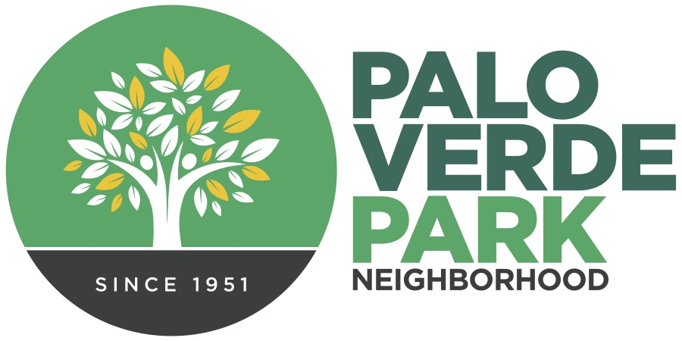
Palo Verde Park
Neighborhood Association
http://paloverdeparkneighborhood.com/

Meeting Agenda
Tuesday, June 14, 2022

President: Mike Southworth
Vice President: Dianne Bustamante
Treasurer: Andy Weiss
Secretary: Rhonda Bodfield
Delegate: Cathy Cromwell/Matt Russell
Delegate: Torey Crandell
Delegate: Patricia Bowers

*Members of the neighborhood council may attend on occasion via telephone or appoint a designee to serve

Notice of public participation
At least 14 days notice shall be provided in advance of any association meeting, barring any item of critical need, and an agenda shall be posted for public review at that time on the association website. All meetings shall be open to the public.
Out of respect for time, speakers are limited to 2 minutes on any topic.
One person speaks at a time, to allow for respectful listening.
No derogatory remarks of others will be tolerated.

- Roll Call and introductions

- Code of conduct

- President’s report

- Officers’ report, as needed

- Presentation by Sgt. Gary Parrish, Tucson Police Department, neighborhood liaison

- Call to the Public

- Adjournment

