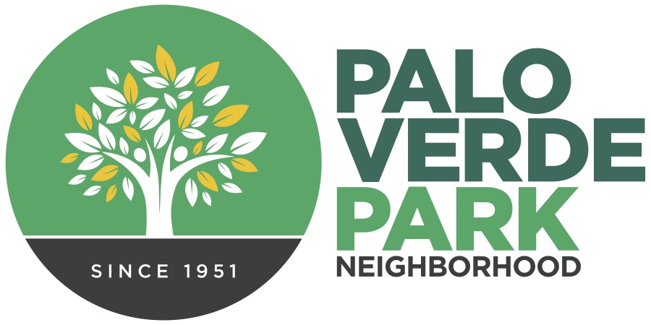
Palo Verde Park
Neighborhood Association
http://paloverdeparkneighborhood.com/

Minutes, January 17, 2023 regular meeting

Present:
Mike Southworth, president
Andy Weiss, treasurer
Rhonda Bodfield, secretary
Patricia Caldwell, delegate
Matt Russell and Cathy Cromwell, delegate
*Vice President Dianne Bustamante and Delegate Torey Crandell also serve on the Council but were unable to attend

Regular order of business: Meeting was gaveled to order at 6:02 p.m., roll call was taken, and gratitude expressed to our hosts, Fountain of Life Church.
President’s/officer’s report: Mike shared about our upcoming events, including the February painting party and noted we are proceeding with planning for ParkFest.
Treasurer Andy Weiss sent in an update noting the bank account balance was $191.80. A few notes:
- November yard sale netted $550.84 to help cover the $415.78 invoice for Xmas signs.
- Thank you Cathy & Matt for the $75 donation in December!
- PNC account has a $10 monthly service charge, so we’ll need to raise additional resources soon to continue to cover that charge.
Minute approval: August minutes from our last formal meeting in 2022, featuring an update from the Parks Department, were unanimously approved.
Elections: It was shared that the existing slate was running again, along with the addition of new Council member Adam, Freden. A motion was accepted from the floor to approve the existing Council on a voice vote without the formality of circulating ballots. The motion was unanimously approved.
Guest presentation: Xochitl Coronado-Vargas, Public Outreach Coordinator for the City of Tucson’s Storm to Shade | City of Tucson, presented preliminary plans for a green stormwater project on the Langley parcel. The project will capture storm flows to support native trees and shrubs, which will complement the pollinator garden and other native vegetation on site. Final design and a timeline were still to come.

Adjournment: Meeting adjourned at 7:01 p.m.

