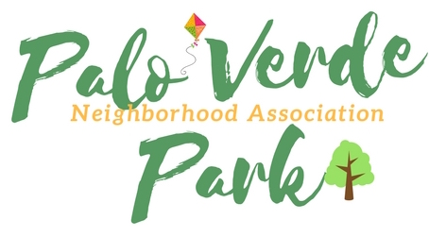
Palo Verde Park
Neighborhood Association
http://paloverdeparkneighborhood.com/

Meeting Agenda
Wednesday, September 19, 2018

Norma Coffman, President
Mike Southworth, Vice President
Jack Kulawik, Treasurer
Rhonda Bodfield, Secretary
Andy Weiss, zone delegate, Riviera Estates
*Members of the neighborhood council may attend on occasion via telephone or appoint a designee to serve

Notice of public participation
At least 14 days notice shall be provided in advance of any association meeting, barring any item of critical need, and an agenda shall be posted for public review at that time on the association website. All meetings shall be open to the public.
Out of respect for time, speakers are limited to 2 minutes on any topic.
One person speaks at a time, to allow for respectful listening.
No derogatory remarks of others will be tolerated.

- Roll Call and introductions

- Code of conduct

- Consideration and appointment of new zone delegate; Toni Lopez Krause to replace Virginia Stanek, representing Mañana Vista

- President’s report

- Officers’ report, as needed

- Approval of minutes

- Approval of sponsorships/donations, as needed:
- approval of County Free Library structure, donated by Debbie Kornmiller
- approval of in-kind donation of association banners, Norma Coffman
- approval of in-kind donation of design work, Rhonda Bodfield

- Presentation by Gary Brauchla, hands-only CPR

- Call to the Public

- Adjournment

