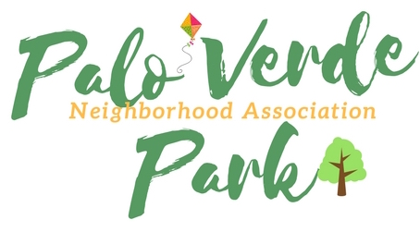Palo Verde Park Neighborhood Association
http://paloverdeparkneighborhood.com/

Meeting Agenda
Wednesday, June 20, 2018

Norma Coffman, President
Mike Southworth, Vice President
Jack Kulawik, Treasurer
Rhonda Bodfield, Secretary
Andy Weiss , zone delegate, Riviera Estates
*Members of the neighborhood council may attend on occasion via telephone

Notice of public participation
At least 14 days notice shall be provided in advance of any association meeting, barring any item of critical need, and an agenda shall be posted for public review at that time on the association website.
All members shall be open to the public.
Out of respect for time, speakers are limited to 2 minutes on any topic.
One person speaks at a time, to allow for respectful listening.
No derogatory remarks of others will be tolerated.

- Roll Call and introductions

- Code of conduct

- President’s report

- Officers’ report, as needed

- Approval of minutes

- Presentation by Tucson Police Department

- Call to the public

- Adjournment

